**Name: Varsha JJ**

**Roll No:48**

**Batch:B**

**Date:21/03/2022**

**NETWORKING & SYSTEM ADMINISTRATION LAB**

**Experiment No.: 1**

**Aim**

Install the latest version of Ubuntu on an Oracle VM VirtualBox.

**Procedure**

Step 1: Click on the Next button in the Welcome window.

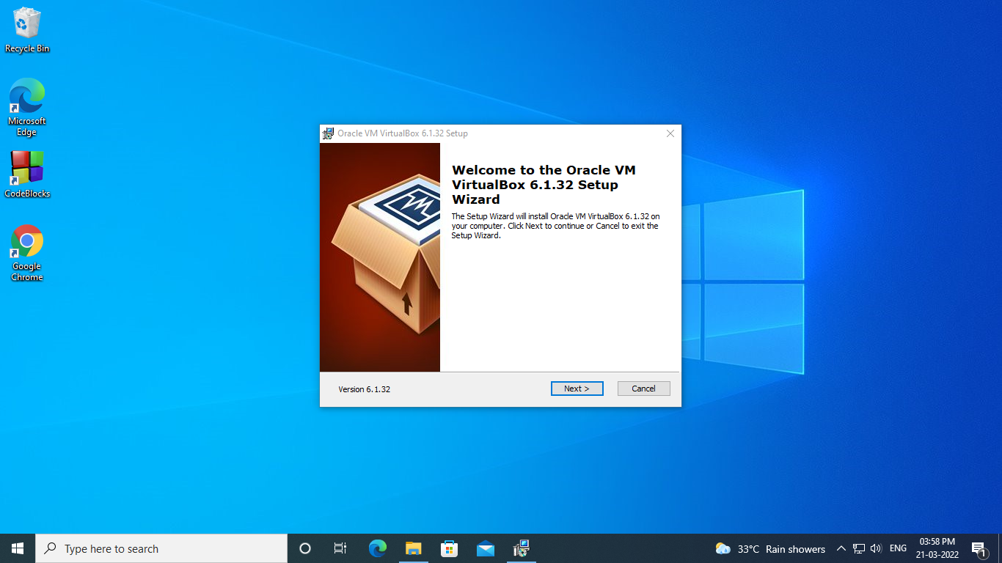

Step 2 : Choose the features that we want to install and then click on the **Next** button.

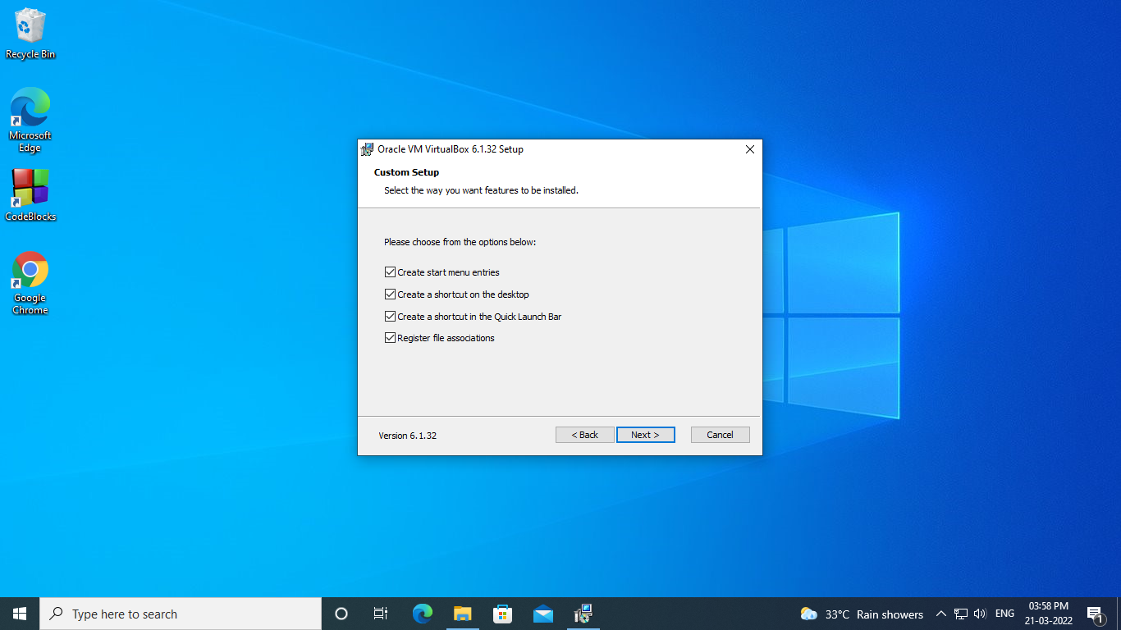

Step 3 : Choose the**installation folder**and click on the**Next** button.

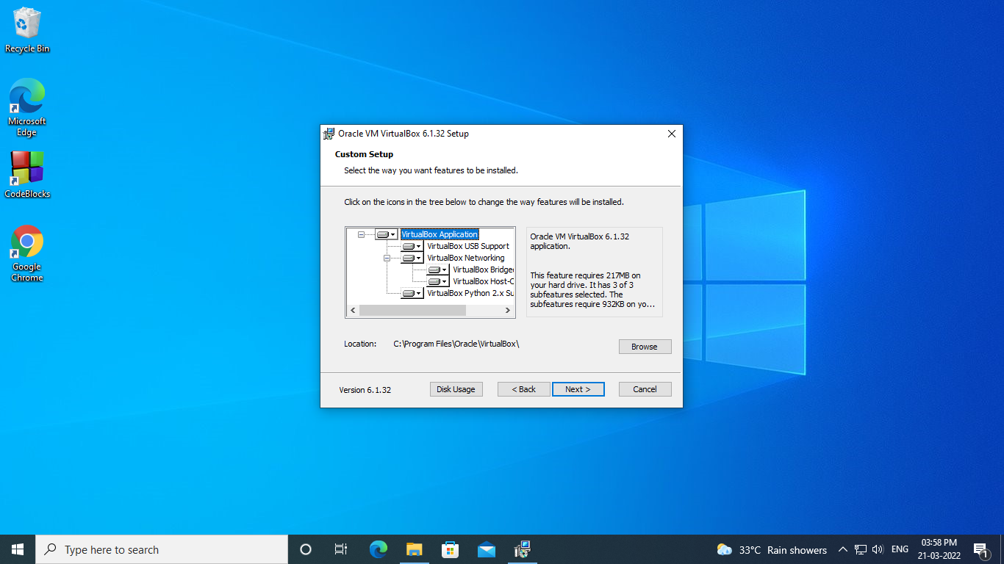

Step 4 :  Click on the Yes button to install the Oracle Virtual Box interfaces.

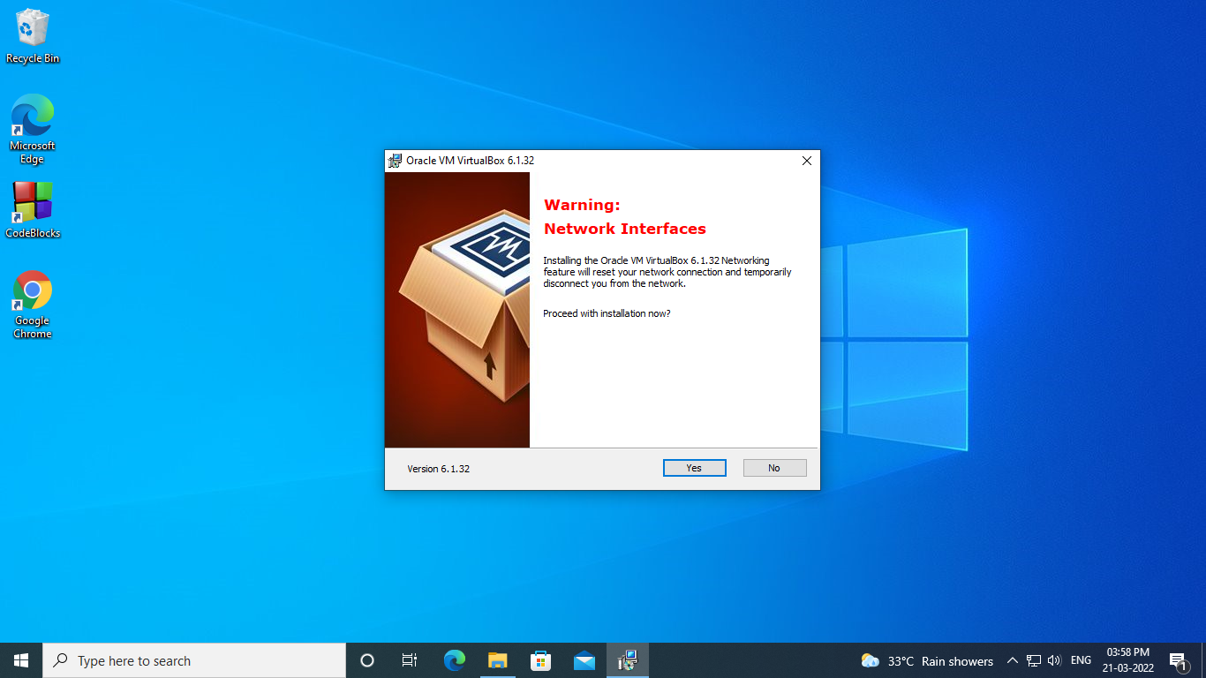

**Step 5:** Click on the **Install** button when it prompted. After that, it will start installing the VirtualBox in our system.

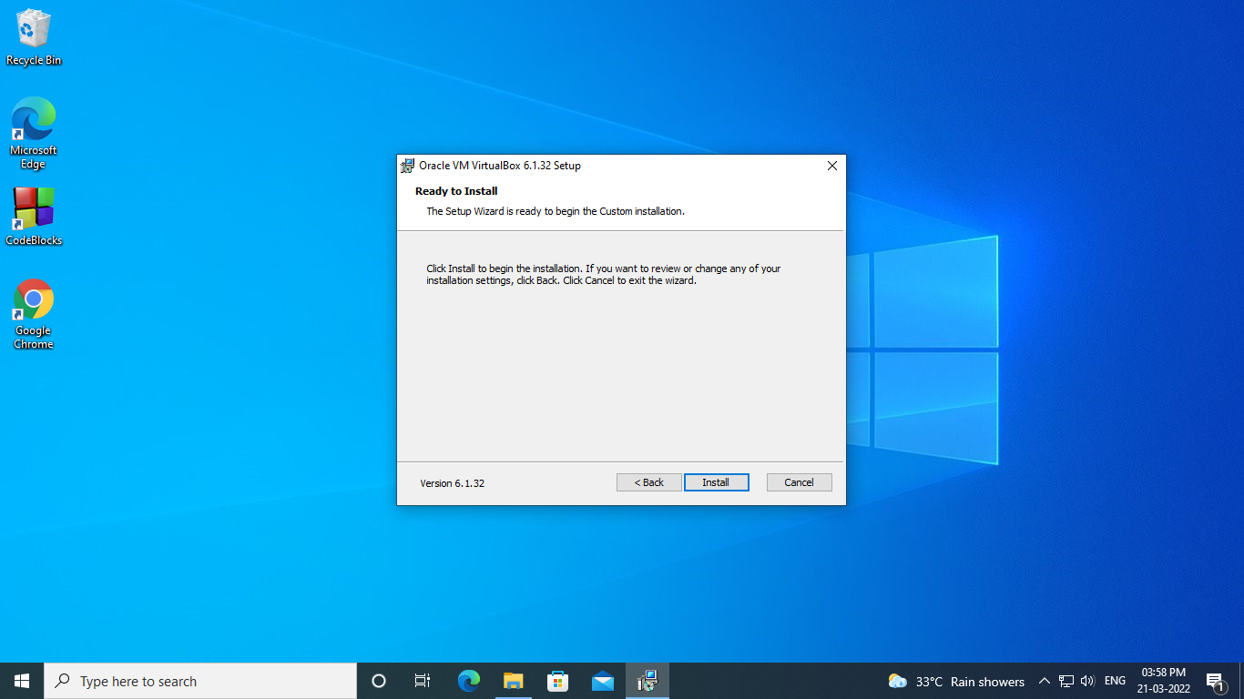

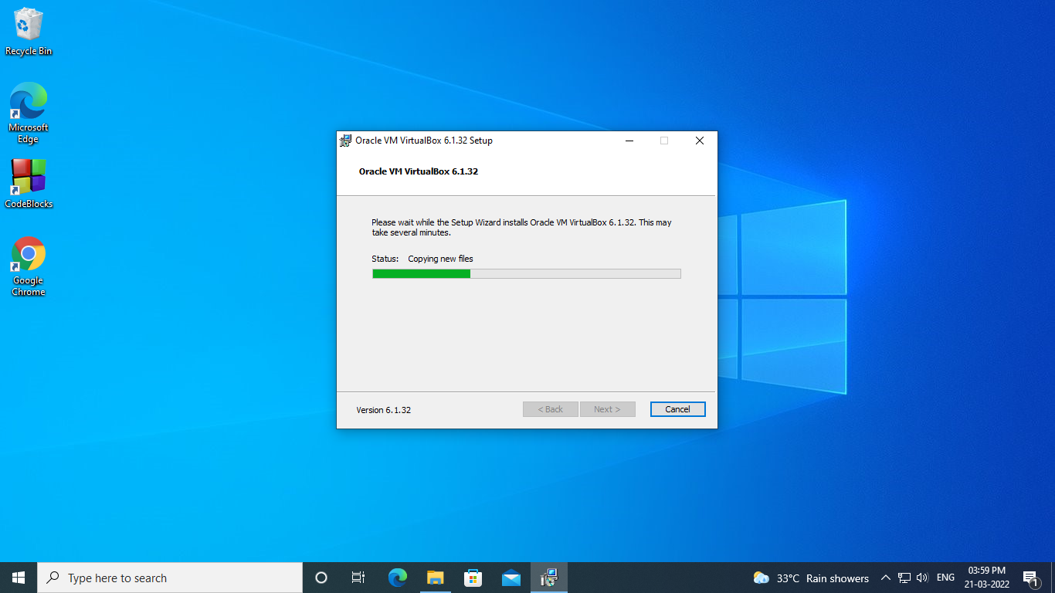

Step 6 : Click finish button.

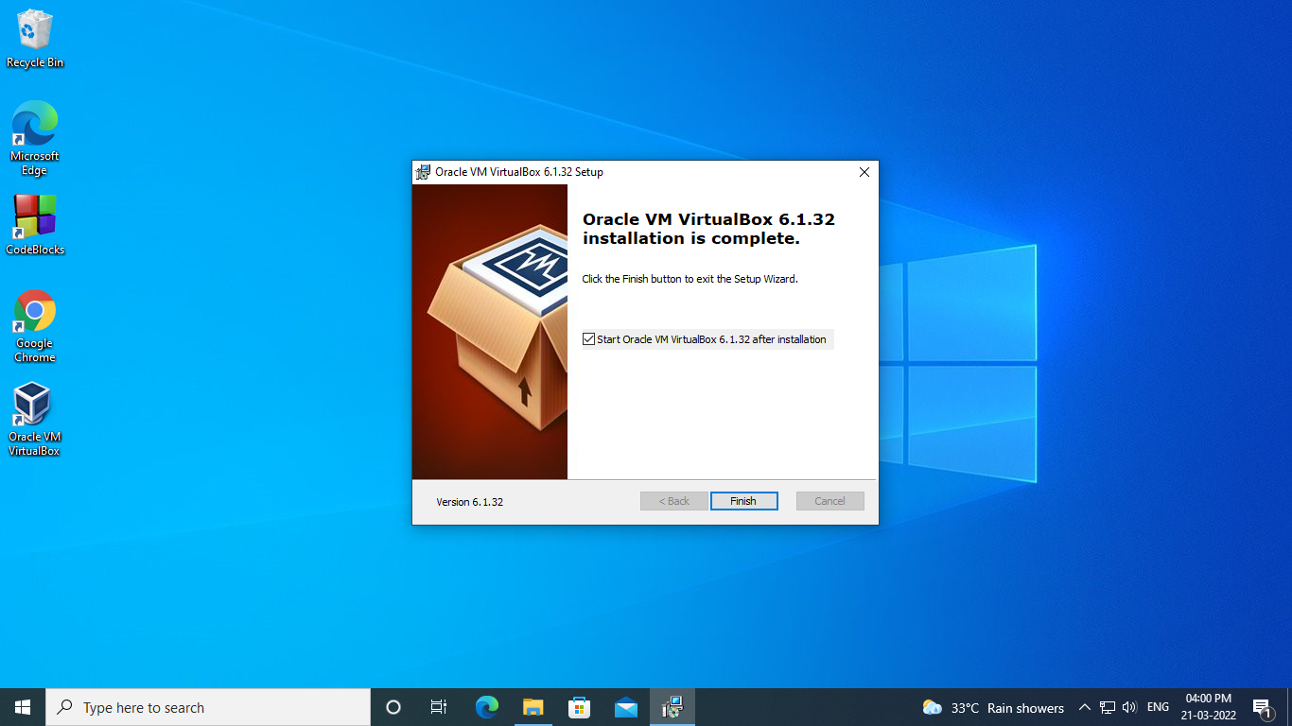

Step 7: Click new button.

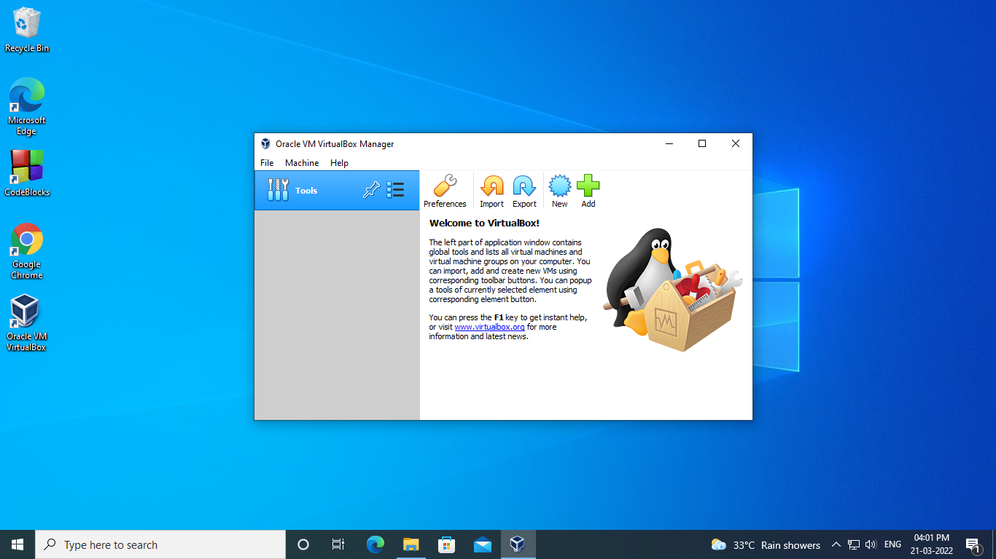

Step 8 : Enter a new name for your operating system in a prompt window.

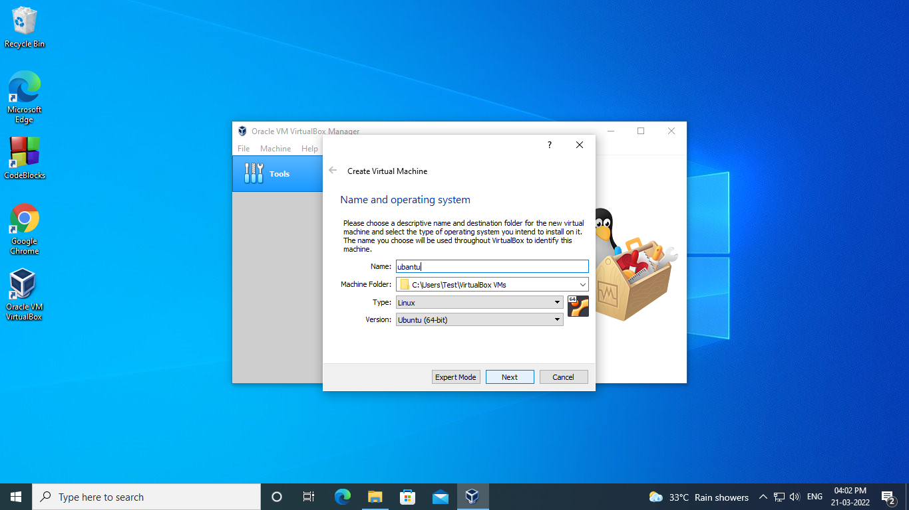

Step 9: Choose the base memory based on your host system RAM size.

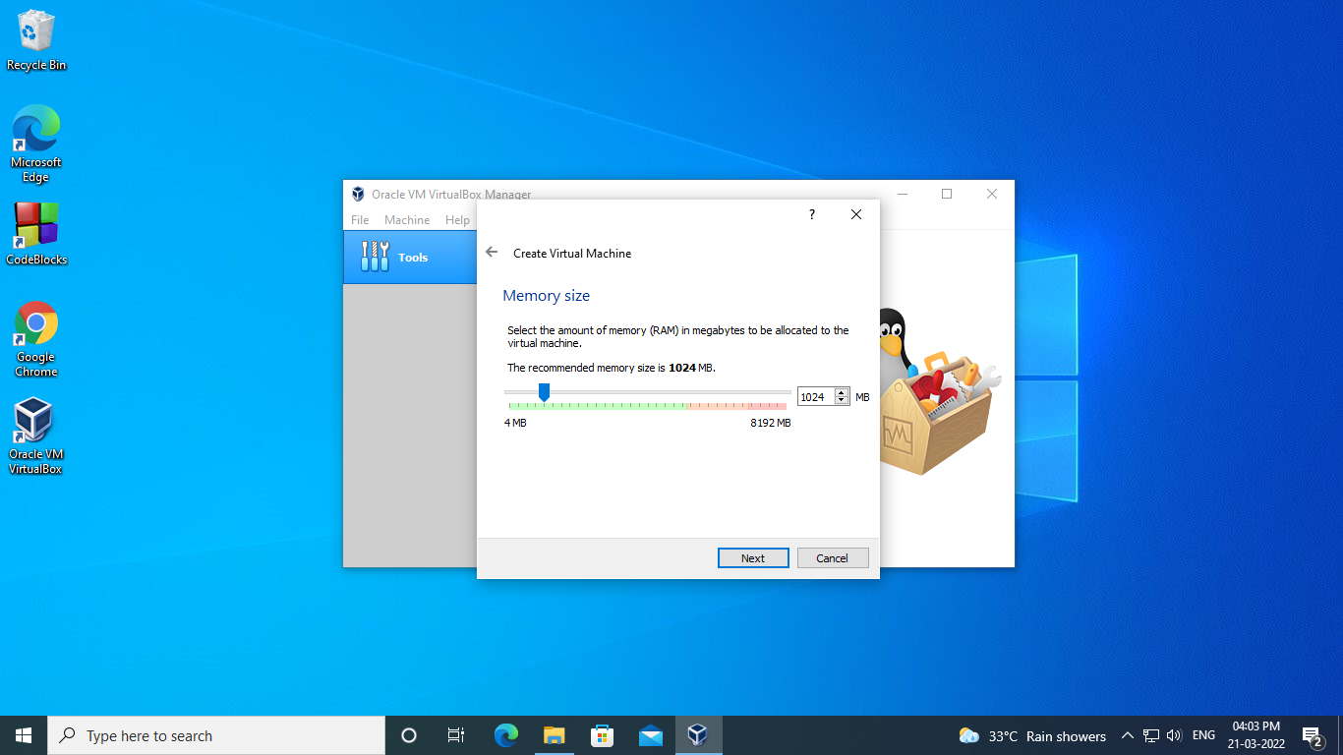

Step 10:  continue to allocate space for virtual hard disks. Virtual disks act as a separate hard disk for the virtual machines residing over the host system hard disk drive.

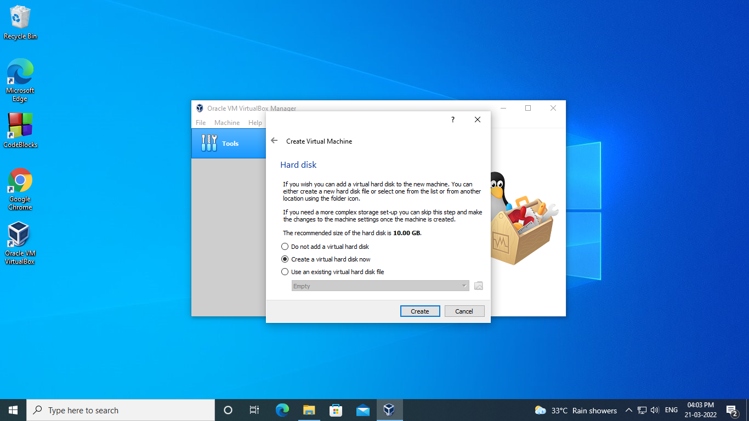

Step 11 : After creating a virtual disk, the next window will prompt you to select the type of file. It decides the method of storing your virtual machine in a file. Select VHD

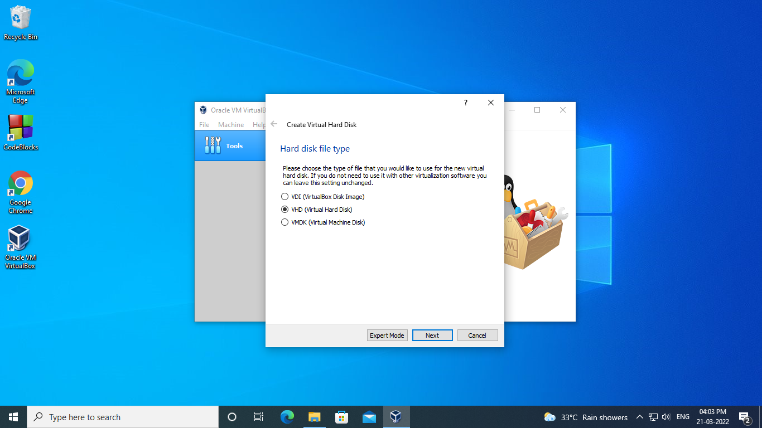

Step 12 : Click on Dynamically Allocated option.

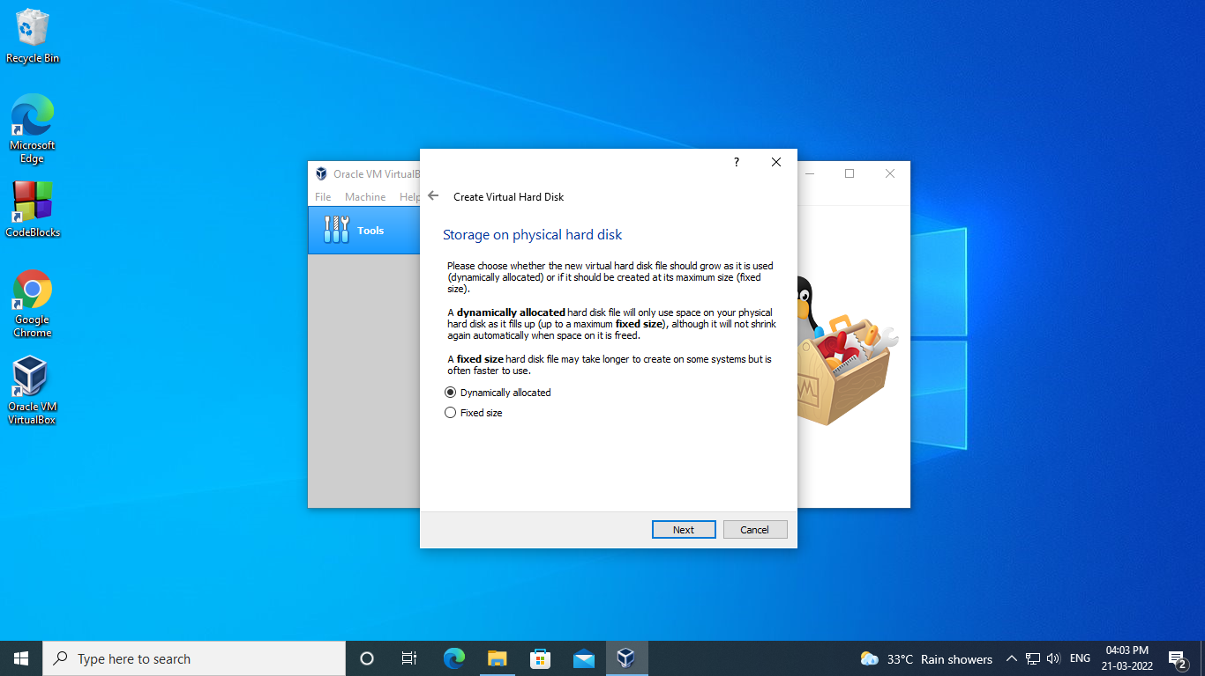

Step 13: Select the path you want to store and allocate the size based on your requirements.

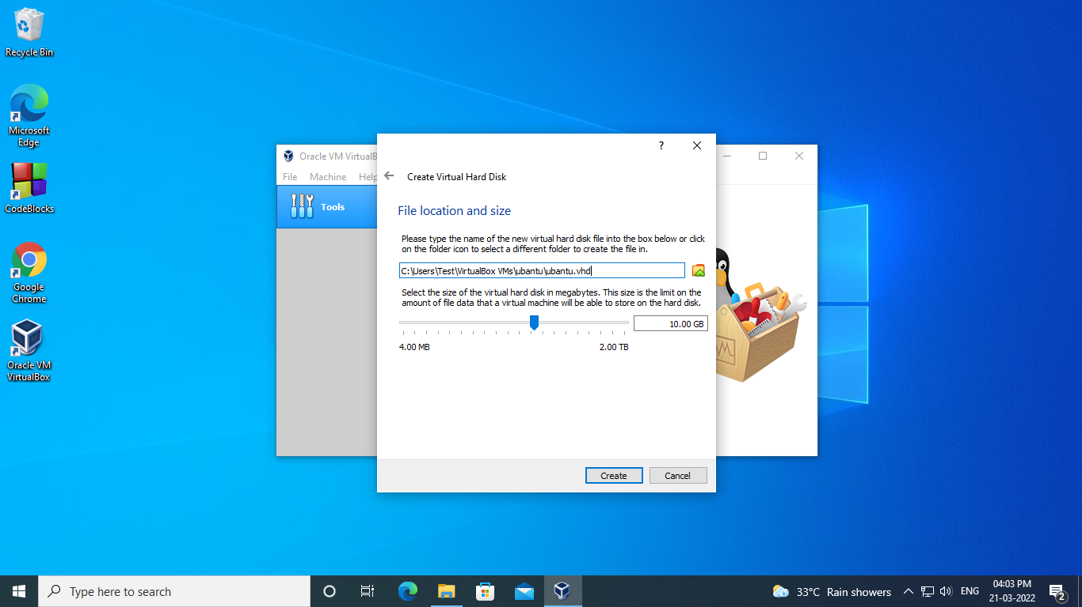

Step 14: Click on create and your virtual machine is now created. On the right side, you can check all the settings and system information about your machine.

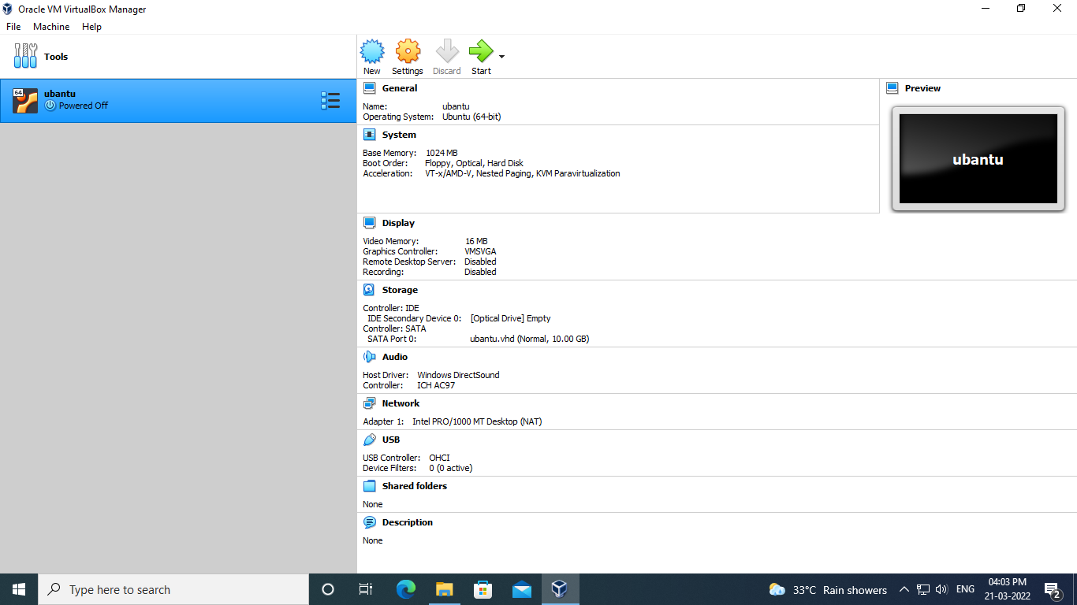

Step 15 : Go to the storage section and then click on the disk icon to import the downloaded Ubuntu 20.04 image.

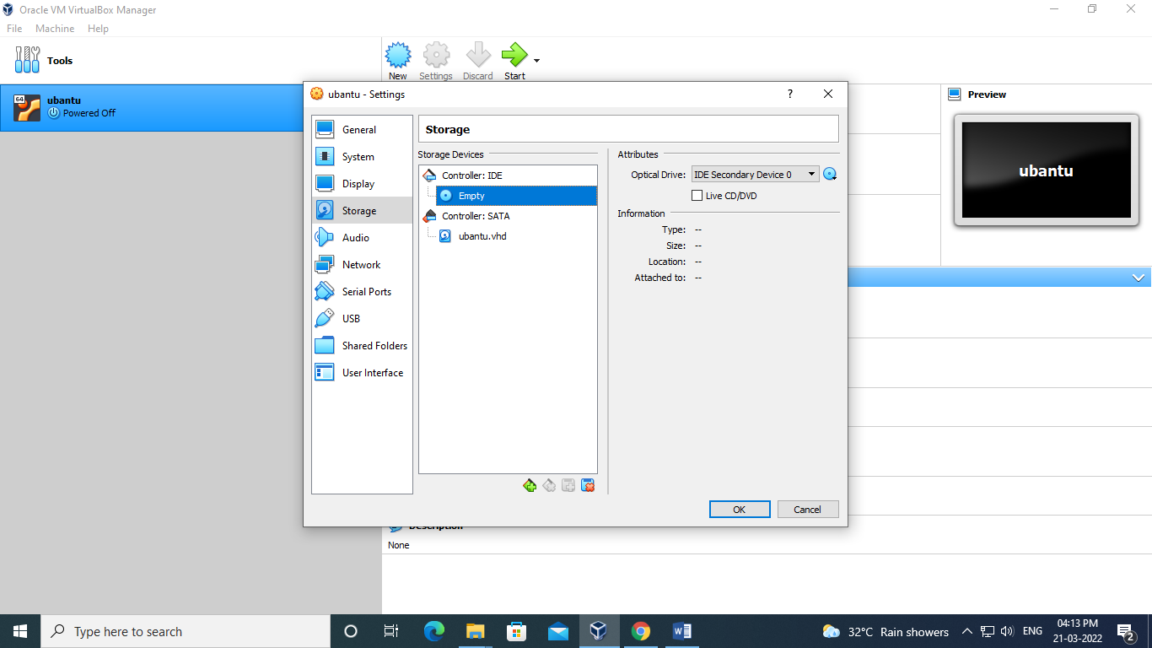

Step 16 : Click on the start button and you’ll notice a black and white screen with an animated rolling wheel and Ubuntu logo at the bottom. It means your Ubuntu installer is about to start.

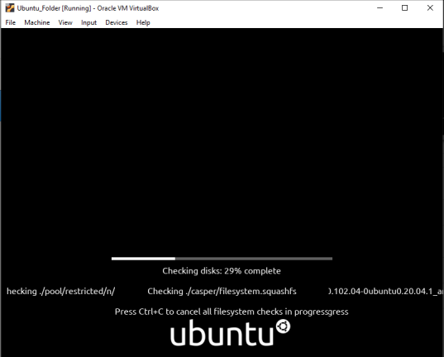

Step 17 : After a few seconds or a minute, the Ubuntu installer will display two options to proceed further. Choose this option if you’re planning to install Ubuntu.

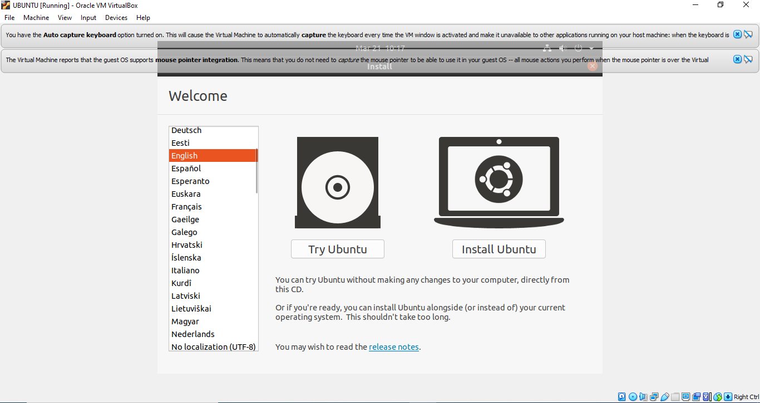

Step 18 : Choose the keyboard layout of your native language.

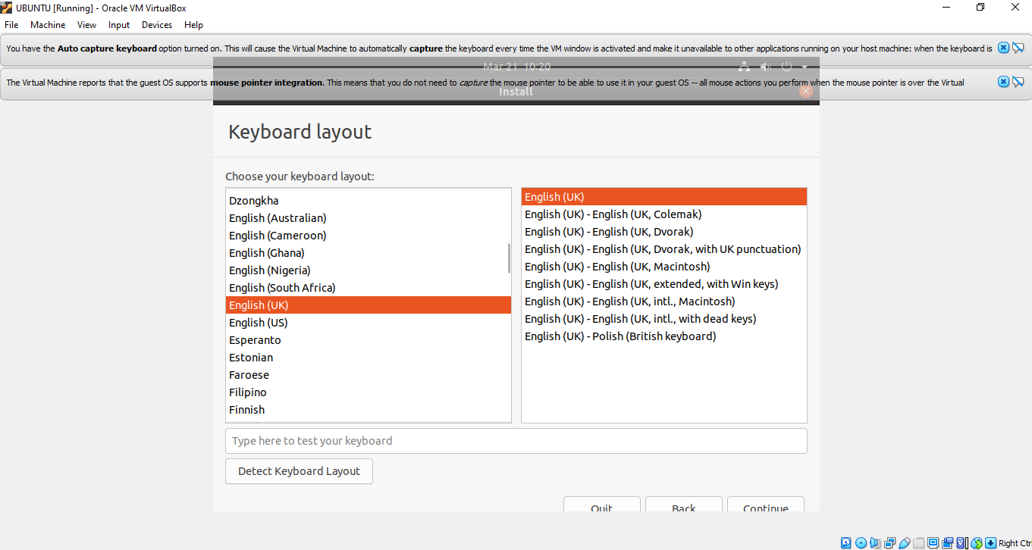

Step 19 : Choose Erase disk and install Ubuntu.

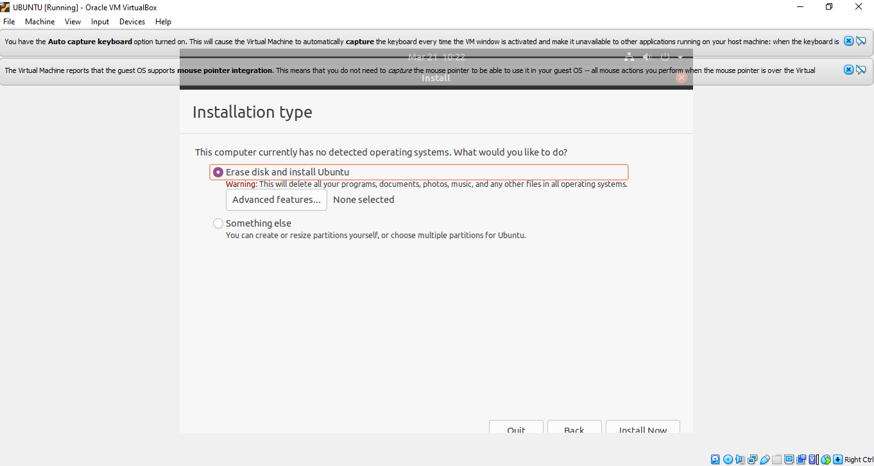

Step 20 : If you’re connected to the internet, the Ubuntu installer will automatically detect and set your location. You can change it either using a map or input field.

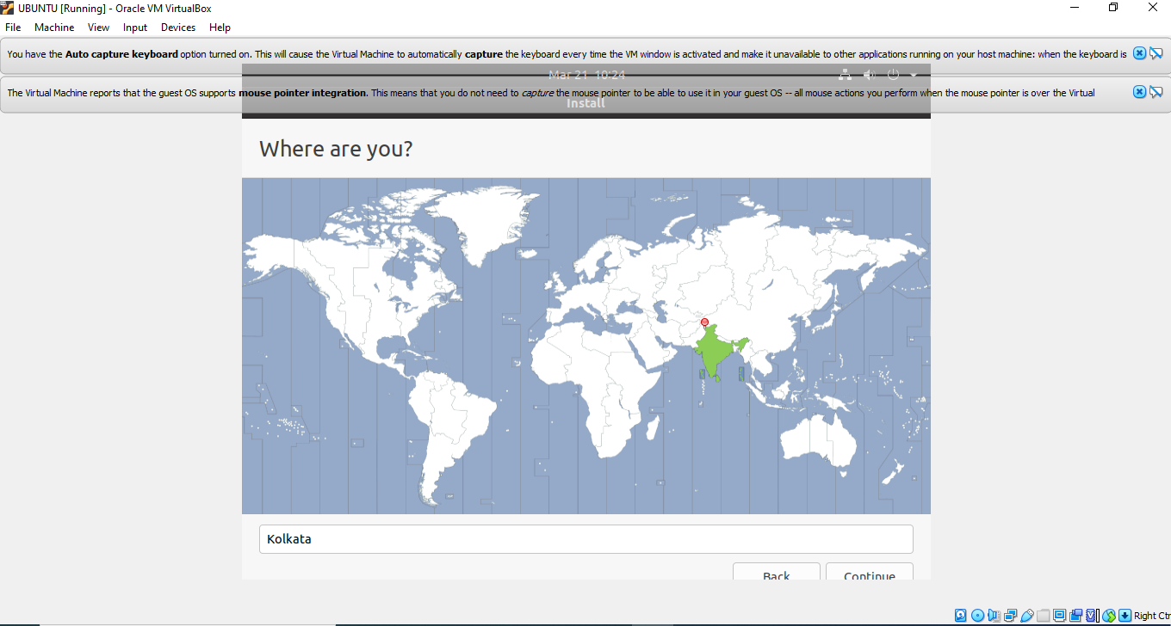

Step 21 : Set your username and password to login to the system. Make sure you choose a strong password with alphanumerics and symbols.

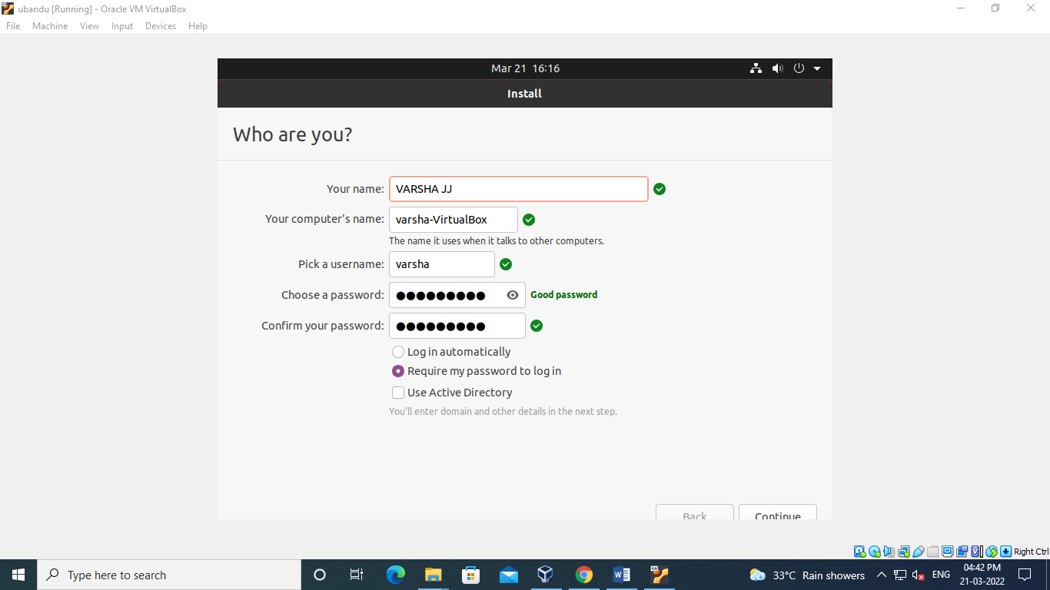

Step 22 : Click on Continue and the installation will start.

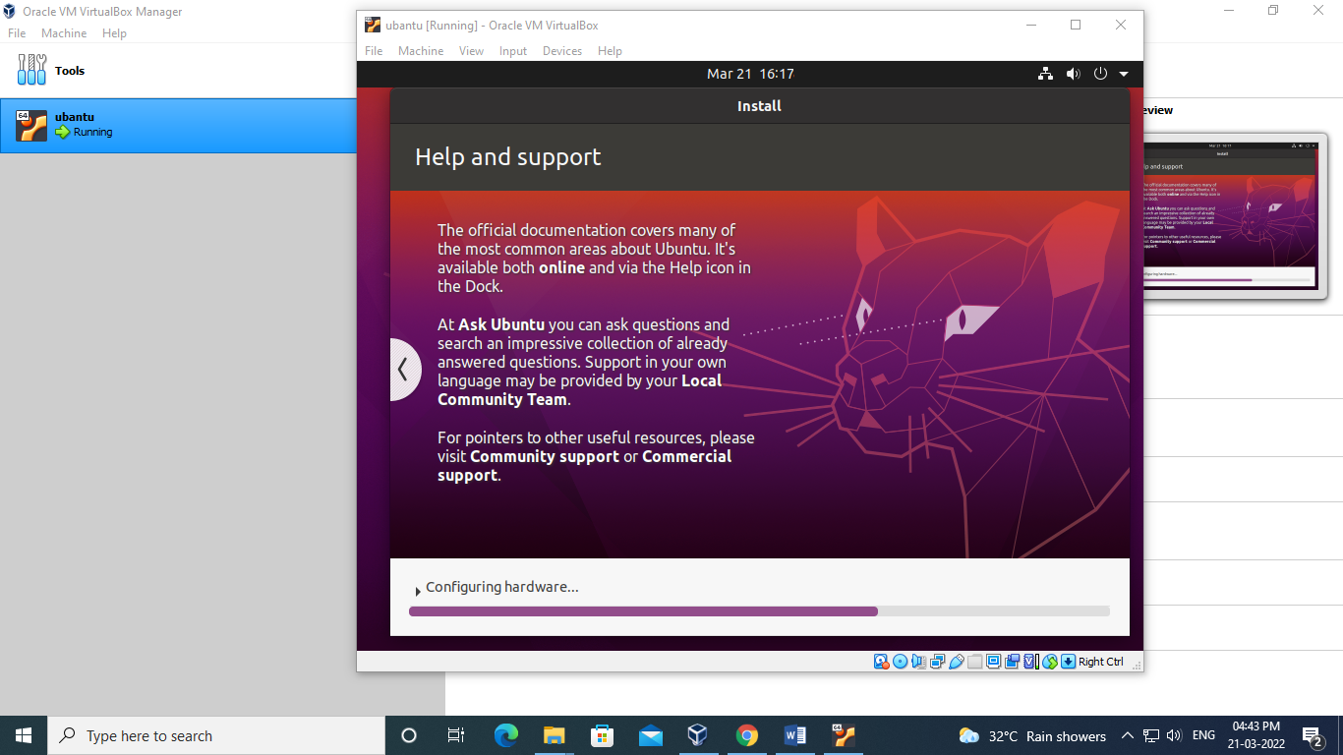

Step 23 : If your installation is complete with no intermediate obstacle, a success notification will pop up. You can now restart and login to your Ubuntu virtual machine.

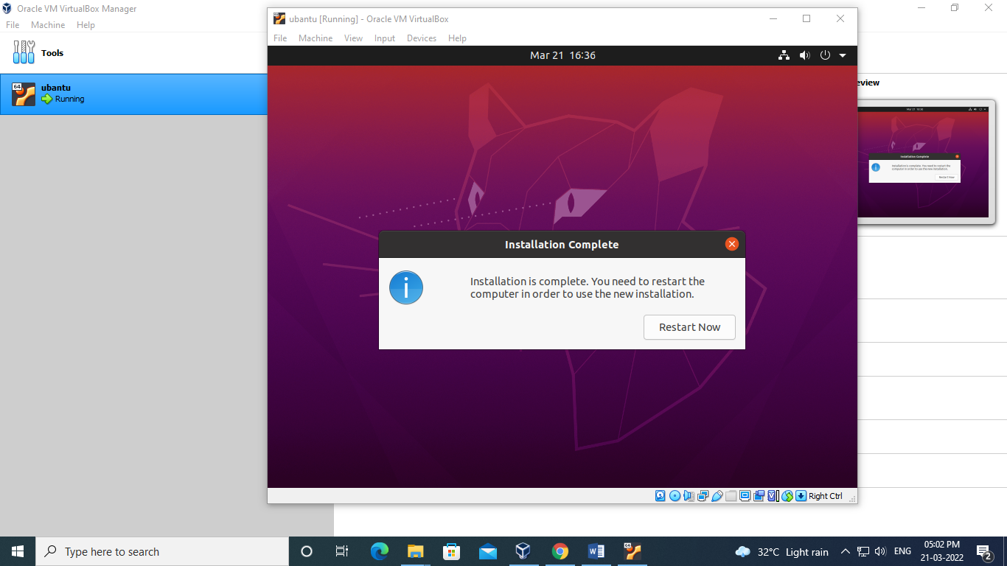

Step 24 : After logging in, you may notice that your Ubuntu desktop screen looks small that hides some parts of opened applications.

**Output Screenshot**

